## User Acceptance Testing

1. **Bug:** Game does not pay out at correct level.

**Description:** When player wins on 1 match, balance does not increase.

When, dice face matches then player’s winning amount will be equals to ‘bet amount + (bet amount * matched faces)’.

**Reproducing bug:** When player wins, winning amount is not properly calculated,

Example: if 5 is betting amount and if one face matches, then as per program execution player gets ‘bet amount * matched faces’ i.e. 5 * 1 = 5 but, player should get 5 + (5 * 1) = 10.

Similarly, if 5 is betting amount and 2 faces matched, then player gets ‘5 * 2 = 10’, but player should get ‘5 + (5 * 2) = 10’.

**Screenshots:**

On running code, firstly all 3 dice gets initialized.

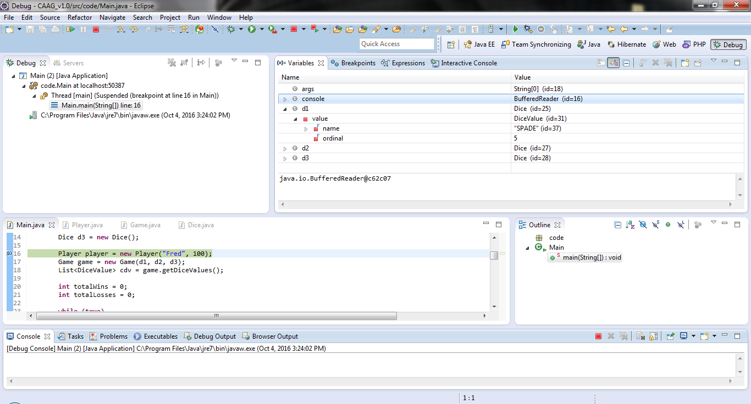

Initially player balance is set to 100, limit is 0.

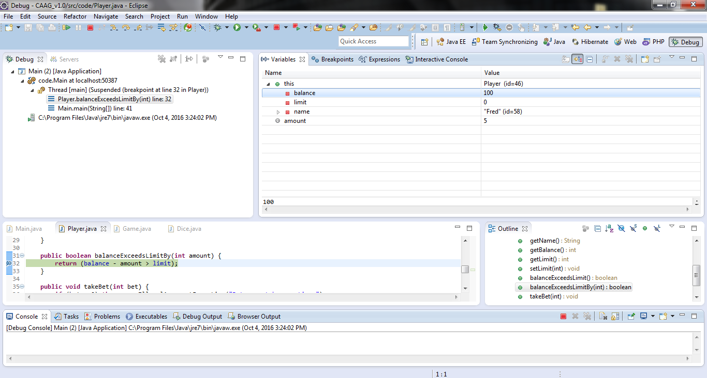

Bet amount is set to 5 and to calculate winning formula used is ‘matches * bet’ due to which bug occurs. The correct formula will be ‘winning = bet + (matches * bet)’.

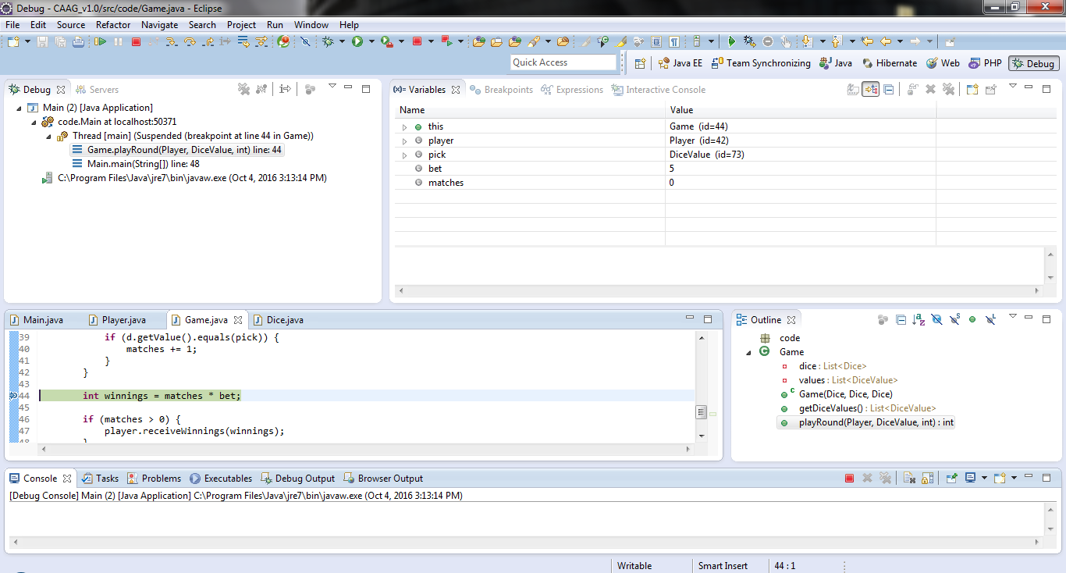

Here we can see if bet amount is 5 and face matched is equal to 1 then, winnings is 5

(bet * matches) but, winnings should be 10

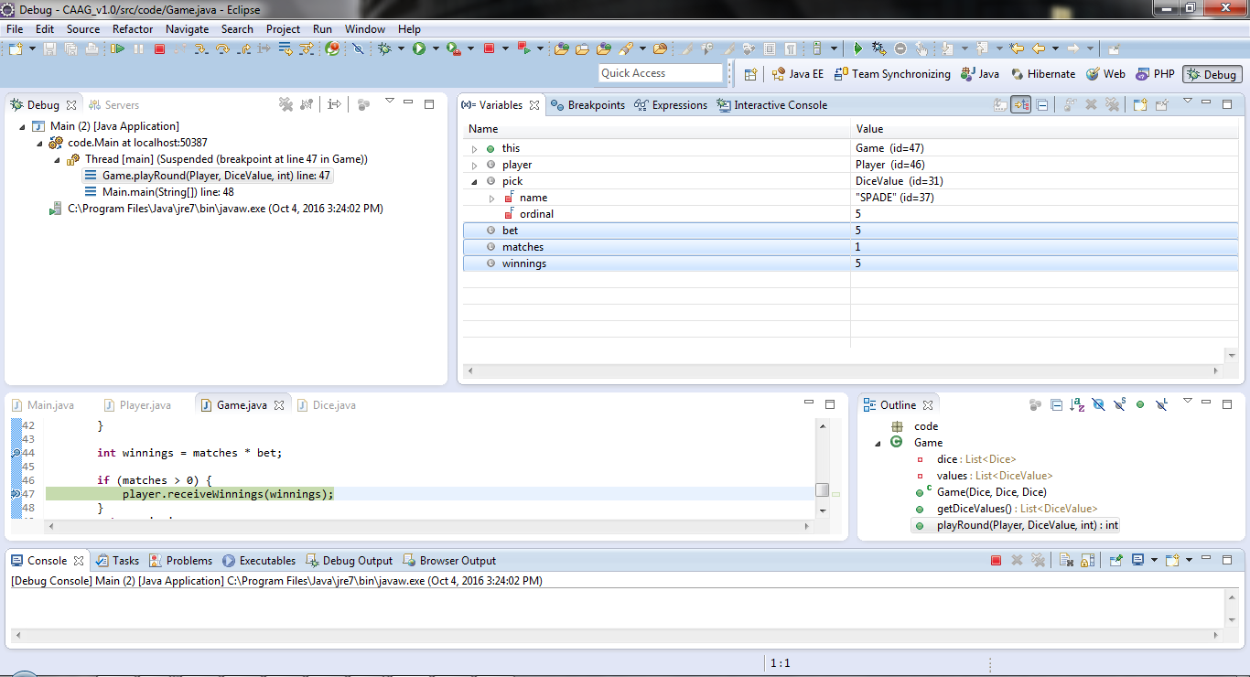

Winning amount is improper as stated above.

